LABOUR BRAND SURVEY
Sent to members (received 21 April)

We want to hear your views on the Labour brand. What follows are a series of questions aimed at discovering:
- what you think is essential to the Labour brand,
- how you'd like to see the brand represented, and
- your views on a selection of existing brands.
Thanks again for taking part.

1. Pick the values you'd like to see associated with Labour. Choose as many as you like.
Enduring  Futuristic  Clever  Friendly  Practical  Classic  Excellence  Different  Honest  Vibrant  Professional  Feel good  Reliable  Bold  Unique  Dedicated  Conservative  Inspiring | Creative  Edgy  Positive  Out there  Consensus  New Zealand  Heritage  Trusted  Sober  Innovative  Integrity  Pacific  Non-confrontational  Caring  People  Fresh  Dependable  Approachable  Cheeky | Artistic  Colourful  Funky  Ordinary  Maori  Diverse  Distinctive  Sophisticated  Unusual  Memorable  Environment  Passionate  Dynamic  Cool  Modern  Happy  Retro

1. Can you describe Labour in six (or fewer) words?
1.
2.
3.
4.
5.
6.

1. What do you think are the essential elements in the Labour visual identity? eg. NZ identity, red, flag or other symbols.

2. Aside from the essential elements you've listed above what other graphical elements would you like to see if possible? eg. Flag, fern, green, blue, stars, Pacifica, Maori etc

3. Who do you think the branding should appeal to? eg. Harmless to everyone/skew younger/skew Pacific etc.

Thanks for answering those questions.
Now we'd like you to look at some overseas logos.
Please respond to the visual identity itself and not what you know about the Party that uses this look. You can say as much or as little about each as you like.
PLEASE NOTE:
These aren't proposals for future Labour Party branding - they're merely examples where we want to know what you like and dislike about the design.


1. How do you feel about the image above?
How do you feel about the image above? I strongly LIKE it
I'm somewhere in the middle
I strongly DISLIKE it

2. Can you explain your reasons for your answer above?

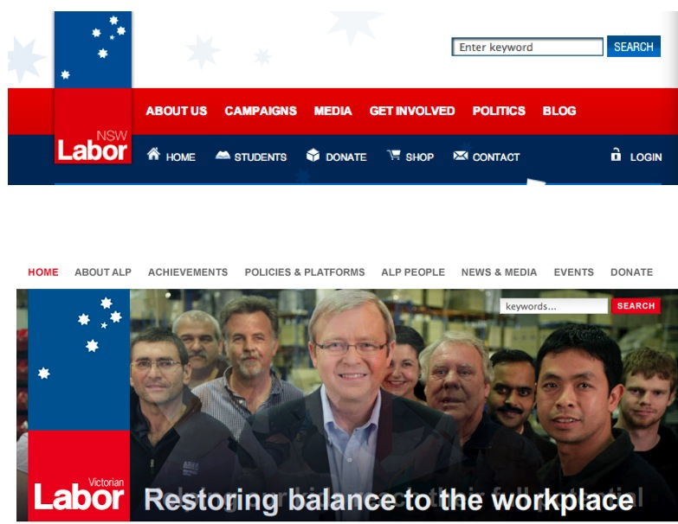

3. How do you feel about the image above?

4. Can you explain your reasons for your answer above?



5. How do you feel about the image above?

6. Can you explain your reasons for your answer above?



7. How do you feel about the image above?

8. Can you explain your reasons for your answer above?
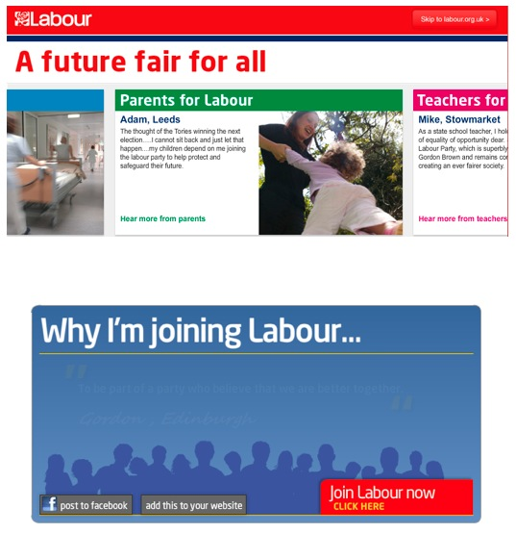

9. How do you feel about the website treatment pictured above?

10. Can you explain your reasons for your answer above?


1. How do you feel about the image above?

2. Can you explain your reasons for your answer above?


3. How do you feel about the image above?

4. Can you explain your reasons for your answer above?


5. How do you feel about the image above?

6. Can you explain your reasons for your answer above?



7. How do you feel about the image above?

8. Can you explain your reasons for your answer above?
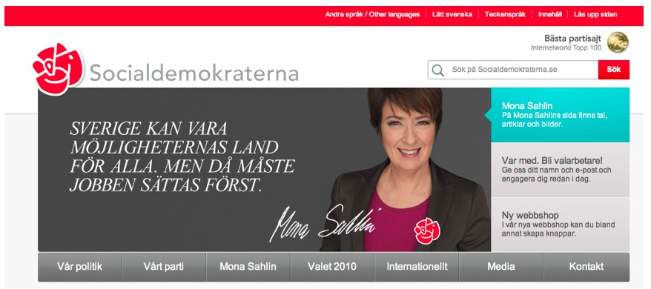

9. How do you feel about the image above?

10. Can you explain your reasons for your answer above?

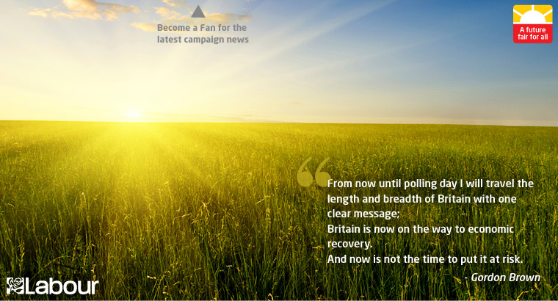

11. How do you feel about the image above?

12. Can you explain your reasons for your answer above?

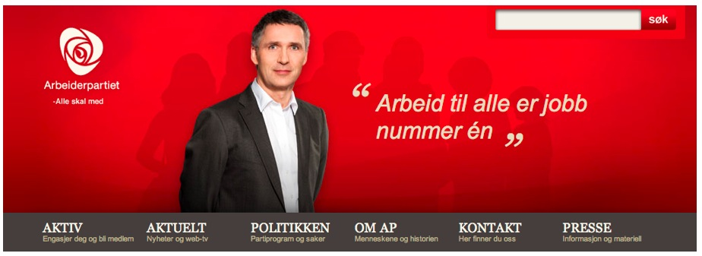

1. How do you feel about the image above?

2. Can you explain your reasons for your answer above?


3. How do you feel about the image above?4. Can you explain your reasons for your answer above?

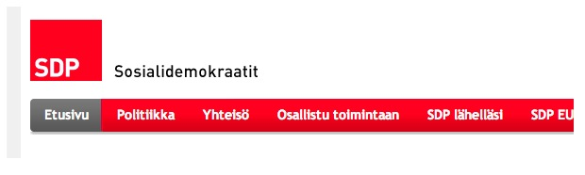

5. How do you feel about the image above?

6. Can you explain your reasons for your answer above?



7. How do you feel about the image above?

8. Can you explain your reasons for your answer above?



9. How do you feel about the image above?

10. Can you explain your reasons for your answer above?


1. How do you feel about the image above?

2. Can you explain your reasons for your answer above?


3. How do you feel about the image above?

4. Can you explain your reasons for your answer above?



5. How do you feel about the image above?

6. Can you explain your reasons for your answer above?



7. How do you feel about the image above?

8. Can you explain your reasons for your answer above?


9. How do you feel about the image above?

10. Can you explain your reasons for your answer above?


11. How do you feel about the image above?

12. Can you explain your reasons for your answer above?



1. How do you feel about the image above?

2. Can you explain your reasons for your answer above?


3. How do you feel about the image above?

4. Can you explain your reasons for your answer above?


5. How do you feel about the image above?

6. Can you explain your reasons for your answer above?


7. How do you feel about the image above?

8. Can you explain your reasons for your answer above?


9. How do you feel about the image above?

10. Can you explain your reasons for your answer above?


11. How do you feel about the image above?

12. Can you explain your reasons for your answer above?

