NZ Police: Hate crimes targeting NZ Jews up 530% from 2022 to 2023

Executive summary:
- Police reported hate crimes targeting Jews in New Zealand increased 583% from 2022 to 2023.
- Jewish New Zealanders are disproportionately targeted for hate crimes. Despite making up only 0.2% of the population, NZ Police Oct-Dec 2023 data shows that:
  - 13% of all reported hate crimes in the Auckland Region were against Jews;
  - 10% of all reported hate crimes in the Wellington Region were against Jews; and
  - 10% of all reported hate crimes in the Tasman Region were against Jews.
- Jewish New Zealanders are 160 times more likely to be the victim of a hate crime than a European New Zealander.
- Jewish New Zealanders are 18 times more likely to be the victim of a hate crime than a Maori New Zealander.
- Jewish New Zealanders are 1.7 times more likely to be the victim of a hate crime than a Middle Eastern New Zealander.
- Hate crimes against Jewish New Zealanders are increasing at a rate more than 5 times higher than the next group of victims, Middle Eastern New Zealanders.

Analysis of NZ Police Hate Crime Data

Background
In late February 2024, New Zealand Police publicly released responses to Official Information Act requests regarding recorded hate-motivated crimes.
The NZ Police working definition of ‘Hate Crime’ is “any offence which is perceived, by the victim or any other person, to be motivated, wholly or in part, by a hostility or prejudice based on a person’s particular characteristic, such as race, religion, sexual orientation, gender/transgender identity, disability, or age”. The flag is created at the time of reporting if NZ Police identify a potential hate motive and data is available since August, 2019.

Analysis

Overall
There were 3,208 hate crimes in 2021, 4,178 in 2022, and 4,711 in 2023. In January 2024 there were 426. This represents an annualised increase of 30%, 47%, and 73%; thus, hate crimes are rising approximately linearly by 23.5% each year (R² = 0.99; p = 0.006).
Antisemitic incidents rose from 12 to 82 (a 530% increase) and then to an annualised count of 108 in 2024 (another 30% increase)).

Regions
Data for the regions show that more populated areas have more incidents in a linear manner (approx 2.3 incidents per 1,000 people; R² = 0.99; p < 0.001)

By victims’ ethnicity / religion
Looking at the data for hate crimes targeting race/ethnicity, we see that Jews are disproportionately targeted with respect to their population. In 2024, for example, Jews were approximately 1.7 times more likely to be the victim of a hate crime than Middle Eastern Kiwis, 3.2 times more likely than a South Asian Kiwi, 5.0 times more likely than an Asian Kiwi, 18 times more likely than a Māori, and 160 times more likely than a European New Zealander.
The attacks on Jews in New Zealand have increased over time more than any other group also. The crimes targeting Jews have increased at approximately 4.8 incidents per 1,000 people each year, whereas the next highest increase was incidents targeting Middle Eastern people, which only rose at 0.9 incidents per 1,000 people each year, on average.
Religion data is available for some of the incidents and shows that New Zealand Jews are also disproportionately targeted in these hate crimes (5.2 incidents per 1,000 people, compared to 3.8 for Muslims, 1.1 for other religions, and 0.3 for Sikhs).

Offenders
Data on the offenders of hate crime shows that Māori are more likely to commit a hate crime per capita than any other group (approx 1.4 incidents per 1,000 population compared to 0.4 for Pasifika, 0.3 for Europeans, 0.2 for Indians, and 0.05 for Asians).
Males are much more likely (76% of offenders) to commit a hate crime, and younger people are more likely to commit an offence (almost 40% of incidents were committed by people under 36 years of age).
In terms of crimes against Jews, the offenders are predominantly Māori (49% of incidents) or European (46% of incidents). The offenders also tend to be slightly older than attacks against other ethnicities/religions (41% are aged 46-55, compared to 15% overall; and only 14% are under 36 years old, compared to 40% in general)

Discussion
In other countries Jews are consistently targeted in hate crimes at a disproportionate rate compared with other ethnicities or religions. The data from NZ Police are aligned with those trends.
More data recorded over longer periods of time, and with appropriate quality checks will provide a better understanding of the relative risks to New Zealand ethnic and religious communities.
The NZ Police data have similar trends to what the New Zealand Jewish Community Security Group has recorded - between Oct and Nov 2023 there was a >1500% increase in recorded incidents, and an increasing number of incidents in the preceding years.

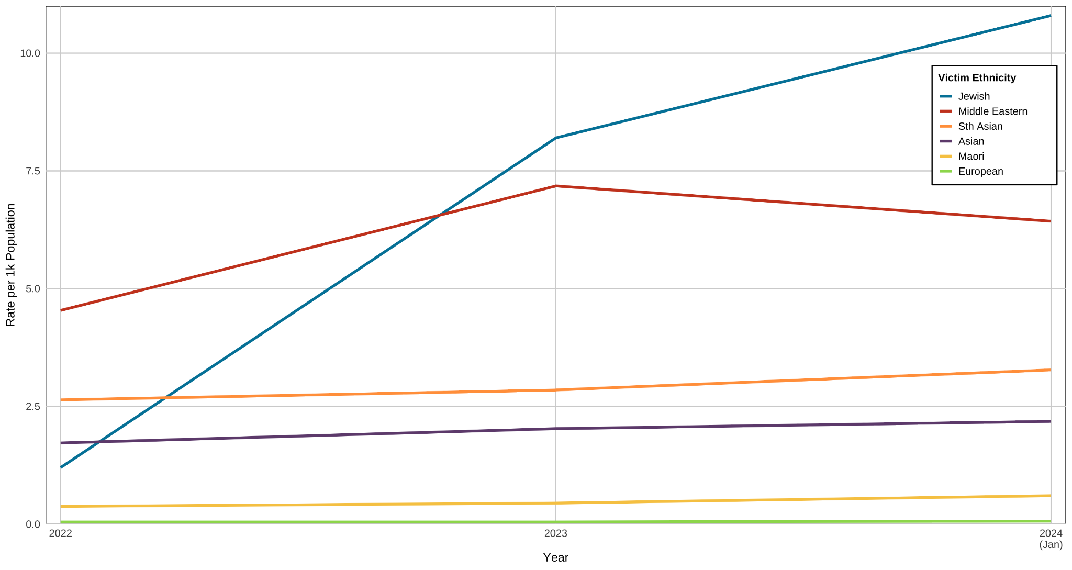
Figure 1: Annualised rate of reported hate crime incidents targeting race/ethnicity per 1,000 population for a selection of victim ethnicities by year. NZ Police Data

NZ Police Data extracts
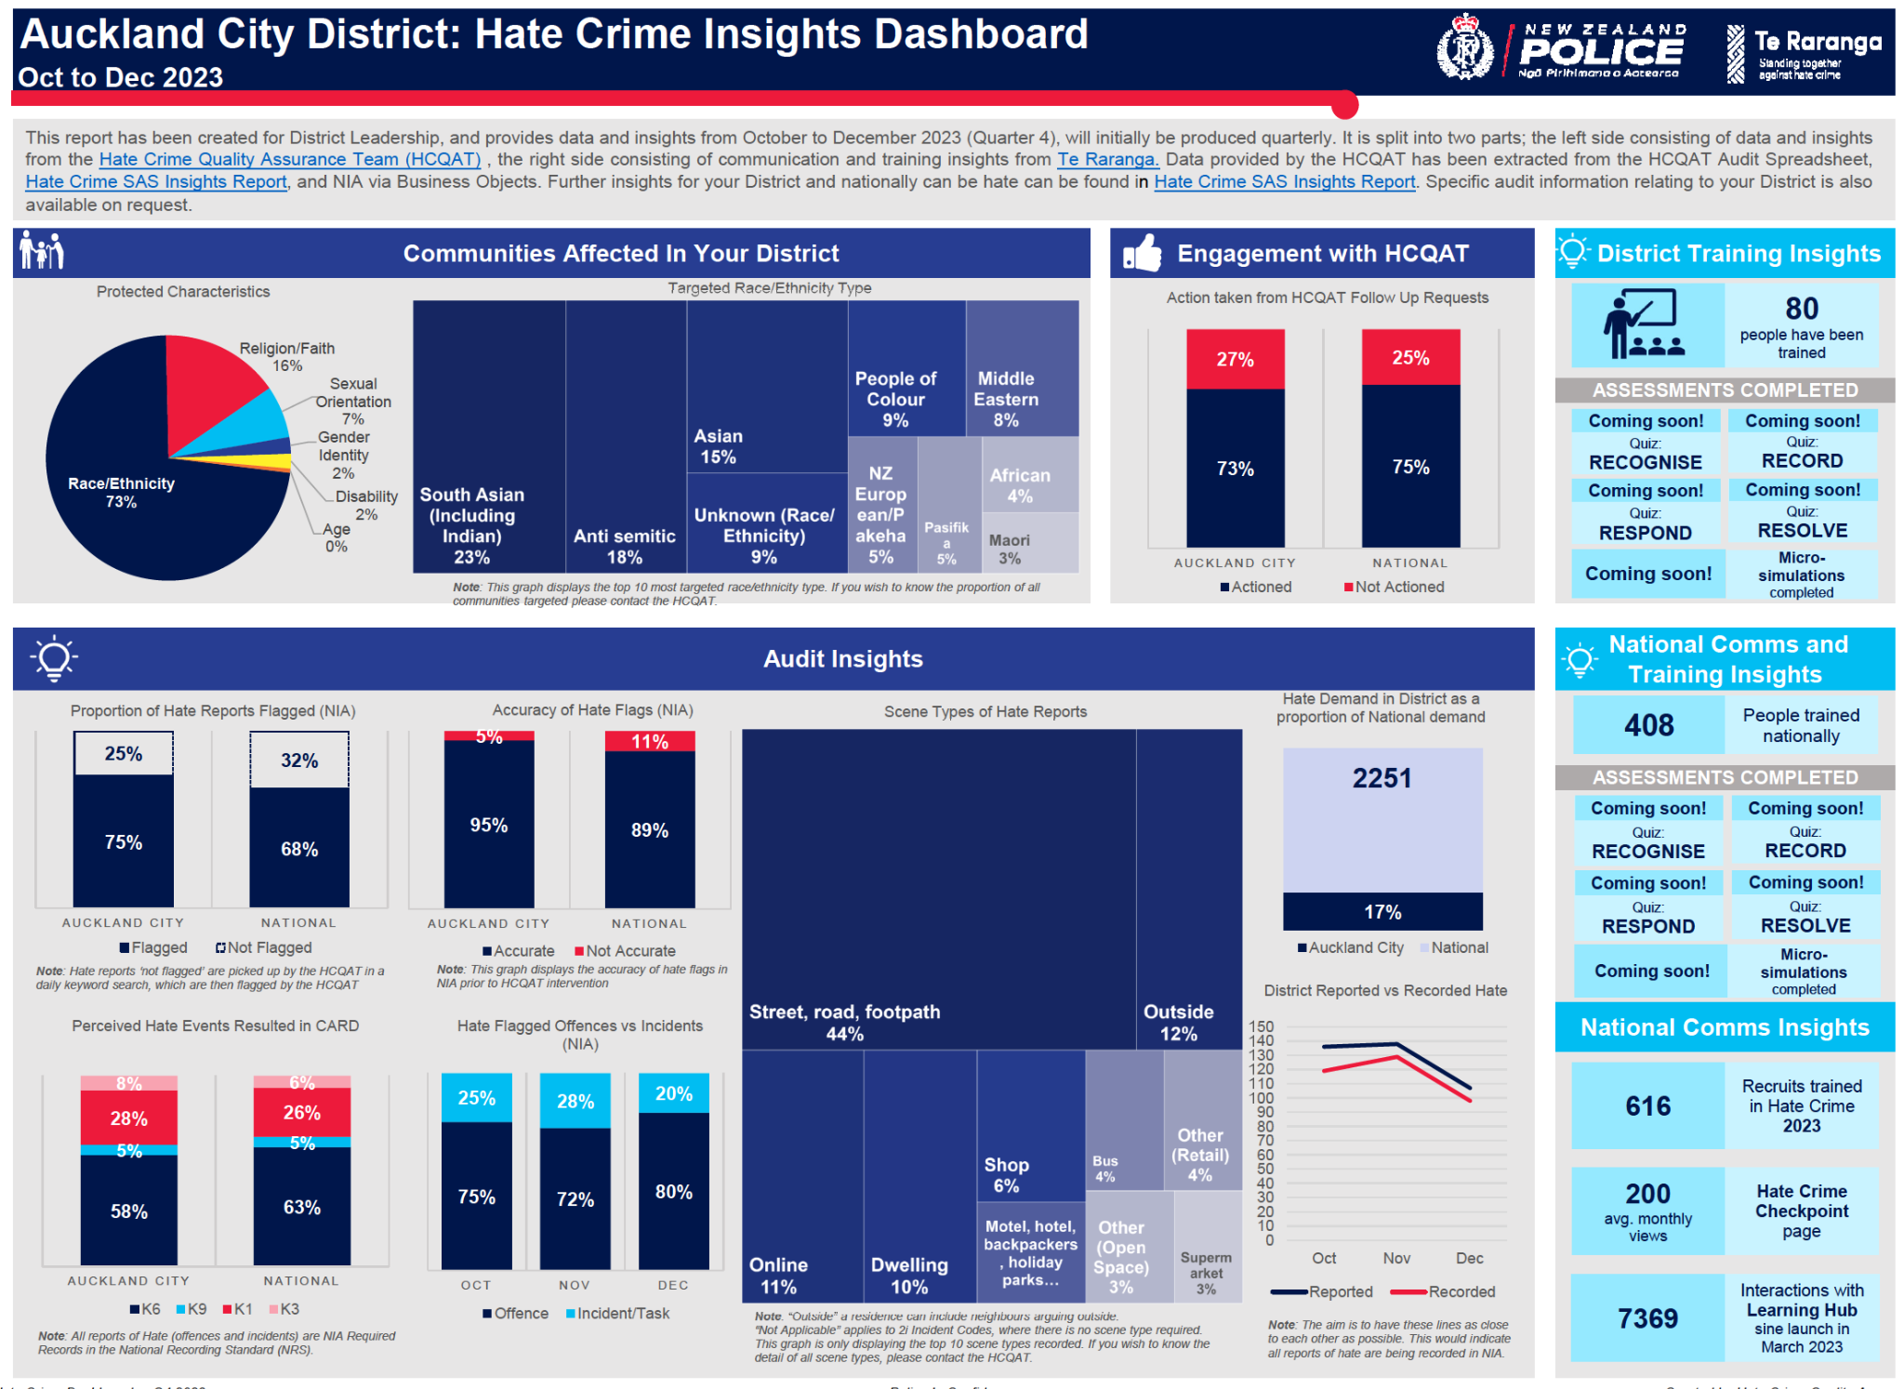
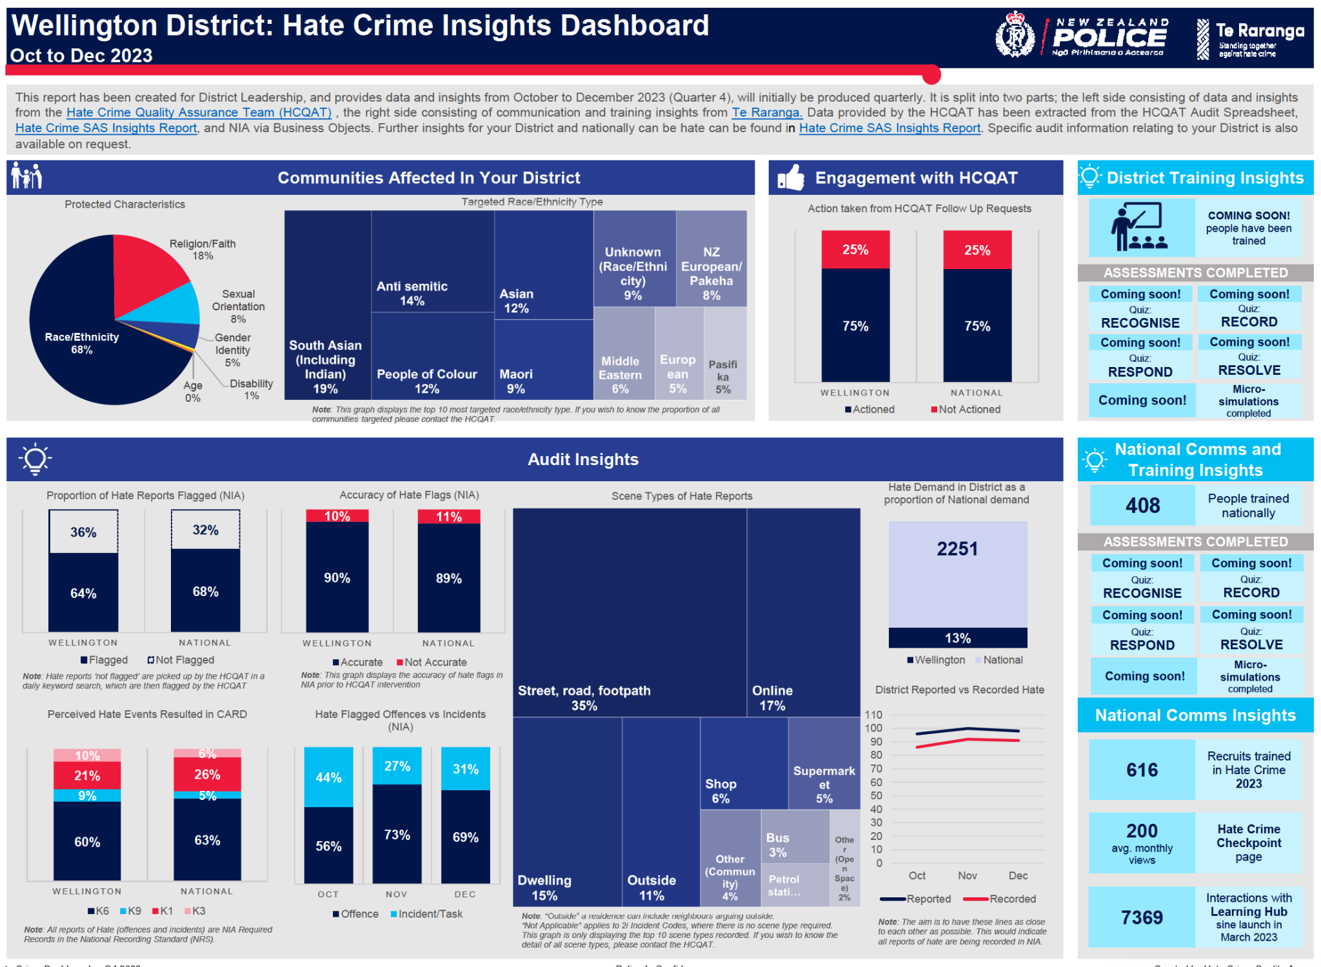
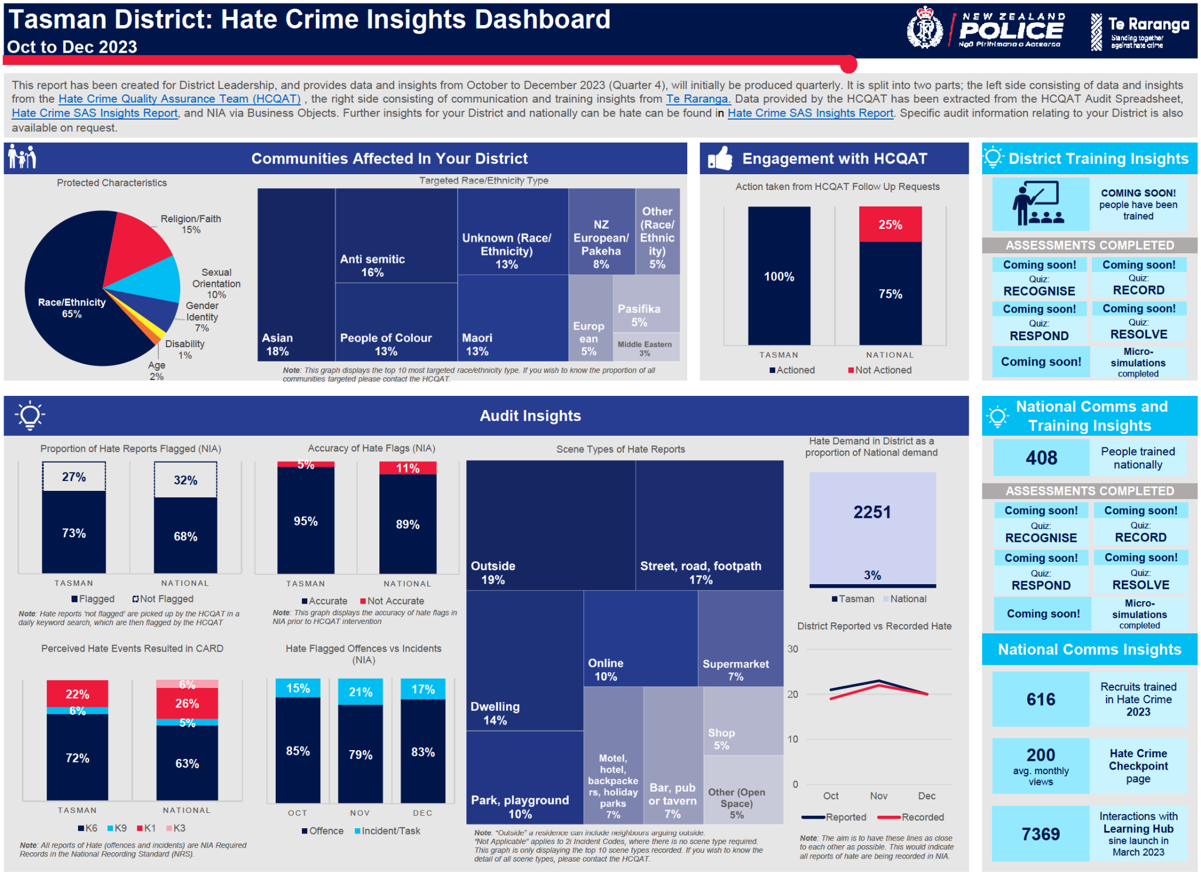

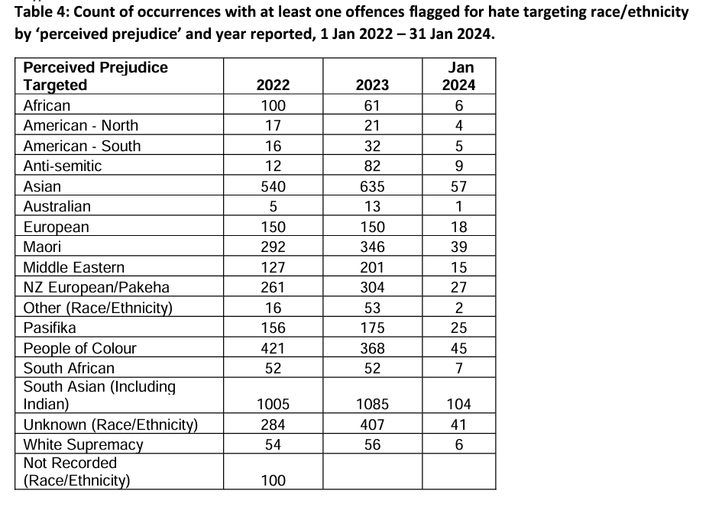

https://www.police.govt.nz/about-us/publications-and-statistics/corporate/information-releases/hate-motivated-crimes-official
https://www.police.govt.nz/sites/default/files/publications/ir-01-23-35388-response-documents.pdf
https://www.police.govt.nz/sites/default/files/publications/ir-01-23-37251-updated-tables.pdf
https://www.stats.govt.nz/information-releases/subnational-population-estimates-at-30-june-2020
https://www.police.govt.nz/sites/default/files/publications/ir-01-23-37251-updated-tables.pdf
https://www.stats.govt.nz/tools/2018-census-ethnic-group-summaries
https://www.police.govt.nz/sites/default/files/publications/ir-01-23-24860-intersectionality-data.xlsx
https://rdc.org.nz/summary-of-religious-diversity-in-new-zealand-2018-census/
https://www.police.govt.nz/sites/default/files/publications/ir-01-23-24860-intersectionality-data.xlsx
NZJC Report: Responding to Hate Crime” Police Workshops 13 November 2020.
CSG report: Analysis of antisemitism in New Zealand during the period from 7 October to 7 November 2023.

